|  |  |  |
| --- | --- | --- |
| **Lyng Primary School P.E Knowledge Organiser** | | |
| **Topic: Basketball** | Year 3 | Autumn 1 |





**"You have to expect things of yourself before you can do them." ― Michael Jordan**

Enquiry Questions

* In what areas of the pitch should we try tricks whilst dribbling?
* How can we keep control of the ball when our body is at different heights?
* What pass selection should we use in certain areas of the court?
* What shooting technique should we use on the court and where?
* When is it best to decide to intercept or block the ball?
* What are the rules of the game of basketball?

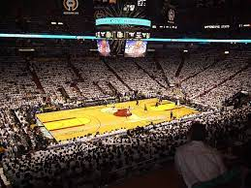 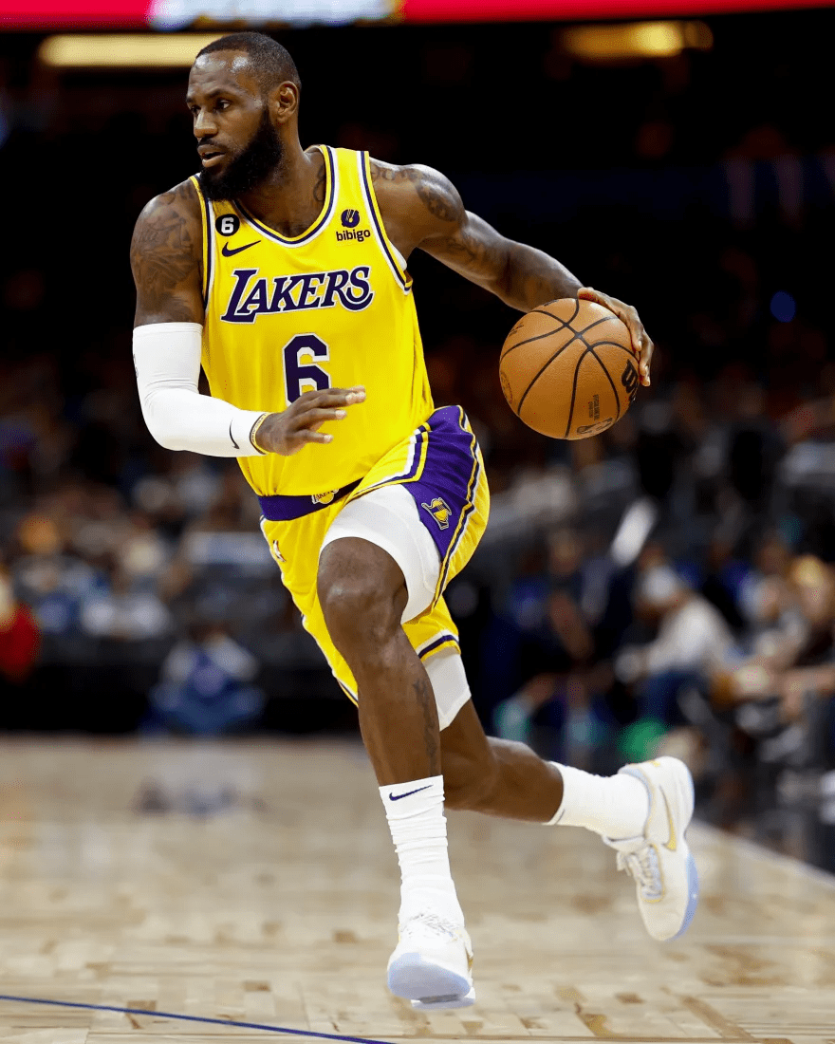

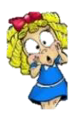

|  |  |
| --- | --- |
| **Key words** | |
| **Spelling** | **Definition** |
| Court | The area where the game takes place |
| Passes | Work through variety passes transferring the ball from one person to another |
| Dribbling | To move whilst in possession of the ball by bouncing it. |
| Shooting | Aiming for the basket to score for the team. |
| Double dribble | Foul play when dribbling with the ball if you stop and hold the ball & then dribble further this is deemed a double dribble. |
| Possession | Retain the ball for the team, so your team is in control and have the ball. |
| Rebound | Follow up from an attempted shot at the basket. |
| Tactics | [Methods](https://www.collinsdictionary.com/dictionary/english/method) that you [choose](https://www.collinsdictionary.com/dictionary/english/choose) in order to be successful, i.e. number of passes made, movement, defensive/offensive shape. |
| Travelling | This is foul play, moving with the ball without bouncing the ball. |

|  |  |  |
| --- | --- | --- |
| **Lyng Primary School P.E Knowledge Organiser** | | |
| **Topic: Basketball** | Year 3 | Autumn 1 |

Learning outcomes:

* Maintain control of the ball, when dribbling or performing a skill
* To improve dribbling from various heights.
* To perform a variety of passes with the correct technique & accuracy
* To perform the correct shooting technique in the correct areas of the pitch
* To apply defensive skills such as blocking, intercept or pressure in a game situation.
* Understand rules and apply all areas of the game into a game situation.

